**Review Worksheet: DNA Evidence and Protein Sequences**

Name: ……………………………………

*Do these questions, using your learning resources. Look at the “marks” to give you an idea of the level of detail required in the response (formative only – does not count towards your grade). At the end, mark your work, correct it, and fill in the reflection section. Questions marked * require you to use reasoning, inferring and application of knowledge, or perhaps extra research to get the answer. It won’t be right there in the text.*

1: State the relationship between DNA, RNA, amino acids and proteins.

(3 marks)

………………………………………………………………………………………………………………….

………………………………………………………………………………………………………………….

…………………………………………………………………………………………………………………

2: How many different amino acids make up proteins?

(1 mark)

*………………………………………………………………………………………………………………*

3: When comparing amino acid sequences, scientists use a single letter rather than the three letters that are usually used to identify them. Why do scientists do this?

(2 mark)

………………………………………………………………………………………………………………….

………………………………………………………………………………………………………………….

…………………………………………………………………………………………………………………

4: Ubiquitous proteins sequences are often compared to assess relatedness and common ancestry between organisms.

1. Define ‘ubiquitous protein’.

(1 mark)

…………………………………………………………………………………………………………………

1. Give an example of a ubiquitous protein.

(1 mark)

…………………………………………………………………………………………………………………

1. Cytochrome C has changed very little over millions of years of evolution. Explain why this might be the case.

(4 marks)

………………………………………………………………………………………………………………….

………………………………………………………………………………………………………………….

…………………………………………………………………………………………………………………

5: What is bioinformatics?

(3 marks)

………………………………………………………………………………………………………………….

………………………………………………………………………………………………………………….

…………………………………………………………………………………………………………………

6: What is annotation, and why is it part of bioinformatics?

(4 marks)

………………………………………………………………………………………………………………….

………………………………………………………………………………………………………………….

…………………………………………………………………………………………………………………

………………………………………………………………………………………………………………….

7: Evolution results from changes in DNA. Given this fact, explain why a comparison of the sequence of amino acids in a particular protein can provide evidence for evolution.

(4 marks)

………………………………………………………………………………………………………………….

………………………………………………………………………………………………………………….

…………………………………………………………………………………………………………………

………………………………………………………………………………………………………………….

8: Which would provide more detailed information? A DNA sequence, or an amino acid sequence? Explain your answer.

(3 marks)

………………………………………………………………………………………………………………….

………………………………………………………………………………………………………………….

…………………………………………………………………………………………………………………

9: Table 10.5 sets out an amino acid sequence from alpha haemoglobin of five different species of animals. Compare each of the amino acid sequences to the one from humans.

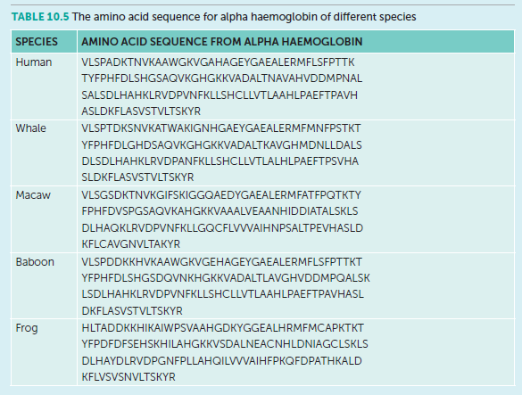

1. Which species’ sequence is the most similar?

(1 mark)

………………………………………………………………………………………………………………….

1. Which species’ sequence is the most different?

(1 mark)

………………………………………………………………………………………………………………….

1. Is this in agreement with current understandings of evolution and common ancestors?

(1 mark)

………………………………………………………………………………………………………………….



10: Which subdivision of the PNS do I belong to? (12 marks)

“I release ACh at the tissues and have no synapses outside of the CNS”

………………………………………………………………………………………………………………….

“I release ACh at the ganglion synapse, then NAdr (NEpi) at the tissues”

………………………………………………………………………………………………………………….

“I release ACh at the tissues and my neurons have one synapse outside of the CNS”

………………………………………………………………………………………………………………….

“My synapses outside of the CNS are organised in ganglia close to the spinal column”

………………………………………………………………………………………………………………….

“My neurons outside of the CNS are pseudounipolar”

………………………………………………………………………………………………………………….

“I release ACh at ganglia close to the effector tissue”

………………………………………………………………………………………………………………….

“I release ACh at a gland that produces Adr and NAdr”

………………………………………………………………………………………………………………….

“I connect to the spinal cord via the dorsal root”

………………………………………………………………………………………………………………….

“I am often under voluntary control”

………………………………………………………………………………………………………………….

“I run through the ventral roots of the spinal cord along most of the vertebral column and have one synapse outside the CNS”

………………………………………………………………………………………………………………….

“My cell bodies are in the dorsal root ganglion”

………………………………………………………………………………………………………………….

“My neurons exit the spinal column mostly from the brainstem, and the base of the spinal cord, not from between vertebrae”

………………………………………………………………………………………………………………….

Go back and mark your work using the marking key provided. What score did you get? /41

*I included enough detail and scientific terminology in my answers.*



*I was able to find information in the text/powerpoint presentation.*

*I was able to reason and infer where the information wasn’t directly in the text (questions with *).*

*I marked my work and wrote down any answers where I missed marks.*